Chapter 19, Solution 20.

Find the y parameters for the circuit in Fig. 19.81.

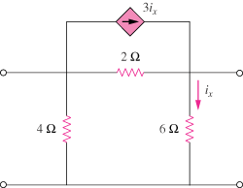

Figure 19.81
For Prob. 19.20.

Solution

To get y₁₁ and y₂₁, consider the circuit below.

3i_{x}

I₁ 2 I₂

+ i_{x} +

I₁ V₁ 4 6 V₂ =0
- -

Since 6-ohm resistor is short-circuited, i_{x} = 0

To get y₂₂ and y₁₂, consider the circuit below.
3i_{x}

I₁ 2

+ i_{x} +

V₁=0 4 6 V₂ I₂

-

Thus,

